RESOLUTION NO.__________

RE: CERTIFICATE OF APPROPRIATENESS UNDER THE
PROVISIONS OF THE ACT OF THE PENNSYLVANIA
LEGISLATURE 1961, JUNE 13, P.L. 282 (53
SECTION 8004) AND BETHLEHEM ORDINANCE NO.
3952 AS AMENDED.

WHEREAS, it is proposed to install new two blade signs at 518 Main Street (Healing Hands).

NOW, THEREFORE, BE IT RESOLVED by the Council of the City of Bethlehem that a Certificate of Appropriateness is hereby granted for the proposal.

Sponsored by: (s)

(s)

ADOPTED BY COUNCIL THIS DAY OF

(s)
President of Council

ATTEST:

(s)
City Clerk

HISTORICAL & ARCHITECTURAL REVIEW BOARD

The applicant is proposing to install two blade signs at
518 Main St. (Healing Hands).
APPLICATION #1:

Tiger Hall 1, LLC/Jennifer Burns
518 Main St.
Bethlehem, PA 18018

OWNER:

__________________________________________________________________________

The Board upon motion by Phil Roeder and seconded by Marsha Fritz adopted the proposal that City Council issue a Certificate of Appropriateness for the following:

- Two new signs to be oval in shape approximately 32” W x 21” H.

2. Cream colored background with burgundy colored lettering.

3. Lettering to be “Serif” letters.

4. Will be a painted border at the perimeter of the signs.

5. Reuse of the metal brackets, painted black.

6. The motion was unanimously approved.

__________________________________________________________________________

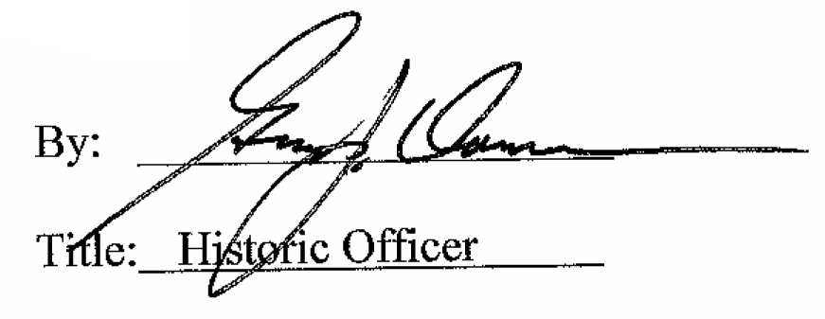

Date of Meeting: October 4, 2017

